Vasukumar Patel
Assignment - 2
PART-A
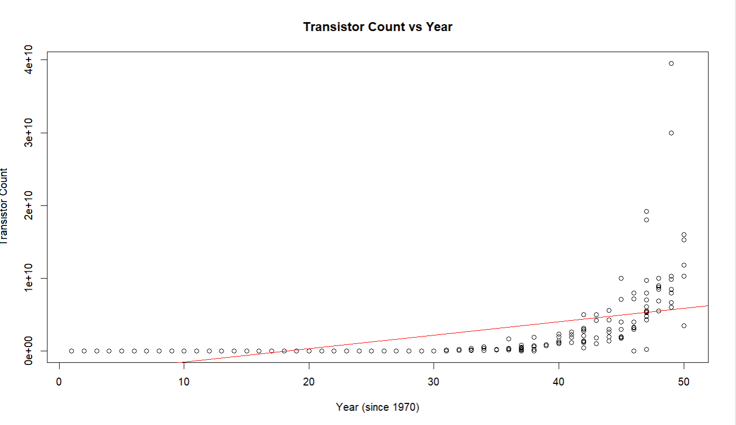

- Does the spread of this data indicate anything meaningful, anything concerning, or nothing at all?
- The spread is meaningful because it shows exponential growth. The transistor counts increase much faster in later years, so the data is not evenly spread around a straight line.

- How would you describe working with this exponential dataset?
- The dataset grows very fast over time, not in a straight line. At first, the transistor counts go up slowly, but later they increase quickly. If we look at the original numbers, the points spread out a lot, so using a simple straight-line model doesn’t work well. That’s why we take the log of the transistor counts—it makes the data easier to understand and lets us use a straight-line (linear) model.

- Can you make any reliable predictions from this dataset?
- Predictions using the linear model on the original scale are not very reliable, because the true growth is exponential.
- Predictions are more reliable if you use the log-transformed data and then back-transform the results to the original scale.
- Even with the log transformation, predictions are usually reliable only for years near the data we already have. Trying to predict far into the future is uncertain because exponential growth can rise very fast and become unpredictable.

- Any problems working with this dataset?

- Non-linearity: The data grows very fast, not in a straight line. A straight-line model on the original numbers doesn’t show the true growth, and predictions can be misleading.
- Uneven spread: Early years have small counts, later years have very large counts. This makes the errors uneven, which breaks the usual assumptions of linear regression.
- Extrapolation risk: Predictions far into the future are not reliable because exponential growth rises very quickly. Even a small mistake in the slope can make big differences in predictions.
- Interpretation: Coefficients from a straight-line model on the original data don’t show the growth rate well. Taking the log of the counts makes the data more linear and easier to understand.

- Can you explain the behaviour of the regression line and why it does not follow the overall trend on the plot?
- The straight-line regression doesn’t fit the data well. It guesses too low for the big transistor counts in later years and too high for the early years. This happens because the data grows very fast, but a linear model expects a constant growth. Taking the log of the counts makes the regression line match the overall trend better.

- Does the scale of the plot axis have any impact on your working with the data?
- The way we scale the plot affects how the data looks. On a normal scale, early values look squished and later values look very large, which can be misleading. Using a log scale spreads the points more evenly and shows the true exponential growth, making it easier to model and predict.

- Are you able to easily identify any outlines?
- It is hard to identify outliers clearly on the original plot because the data grows very quickly. A log scale makes the points easier to compare and makes unusual values stand out more.

- Identify some outliers (max 2-3), and record those data points by CPU name. You will look for them again in Part B to see if you would still classify them as an outlier.
- Zip CPU (2016)
- F21 (1997)
- MuP21 (1994)

PART-B

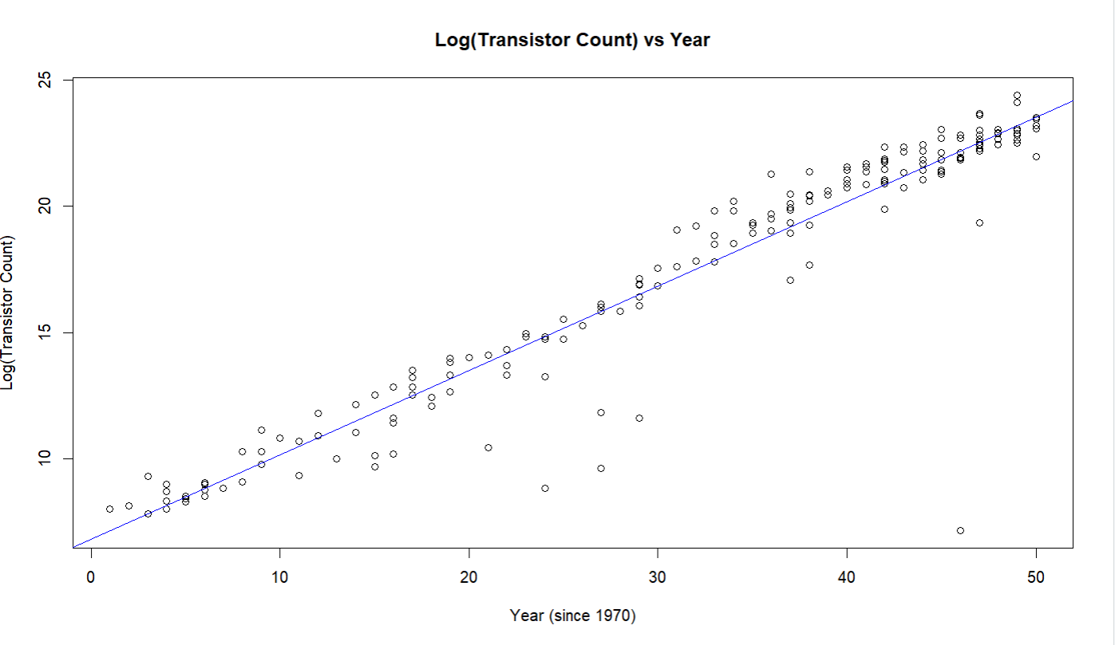

- Does the spread of this data indicate anything meaningful, anything concerning, or nothing at all?
- The spread of the data is meaningful.
- The points show a clear upward curve rather than forming a straight-line pattern, which suggests the relationship is not linear. As the years increase, the transistor counts grow much faster, causing the data to spread out more.

- How would you describe working with this log-linear dataset, as compared to the exponential data in Part A?
- Working with the log-linear dataset is much easier and more appropriate compared to the exponential data in Part A.
- In Part A, the data showed an exponential growth pattern, making the linear regression a poor fit and harder to interpret.
- After applying the log transformation, the data becomes approximately linear, so the points align more closely along a straight line.
- This makes the regression model more accurate, easier to analyse, and more reliable.

- Can you make any reliable predictions from this dataset?
- Yes, reliable predictions can be made, but with some limitations.

- Any problems working with this dataset?
- Even after the log transformation, the data may still show some variability and not perfectly follow a straight line.
- There may be outliers that can affect the regression results.
- The model assumes the exponential trend continues, which may not always be true in real-world scenarios.

- For the data points that you identified in Part A as outliers, would you still classify them as outliers now?
- No, they may not all still be classified as outliers.

- Why or why not?
- Because the log transformation makes the data fit better.
- In Part A, we used a straight line on exponential data, so some points looked far away outliers.
- After taking the log, the data becomes more like a straight line.
- So those points are now closer to the line and don’t look like outliers anymore.

PART-C

- How "close" is the predicted value to the actual averaged value?
- The predicted value is compared to the actual average using the absolute difference and percentage error.
- The closeness depends on the percentage error calculated from the model.

- What empirical method was used to determine this?
- The empirical method used is linear regression on the log-transformed transistor counts, followed by back-transformation using exp() to return to the original scale.

- Demonstrate your calculations (if any) for the above method that was used.
- difference <- abs(predicted_value - actual_average)
- percentage_error <- (difference / actual_average) * 100

- Difference = ∣ Predicted Value − Actual Average ∣

- Percentage Error = ( ( ∣ Predicted Value−Actual Average ∣ ) / Actual Aeverage ) x 100

- Screenshots of the code (Full Code) :
